【例4-71】二维中值过滤
I = imread('eight.tif');
J = imnoise(I,'salt & pepper',0.02);
K = medfilt2(J);
imshow(J)
figure, imshow(K)
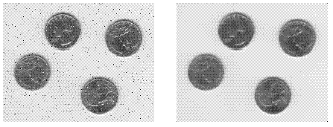
二维中值过滤

